The following family size and annual income criteria will be used for determining eligibility:

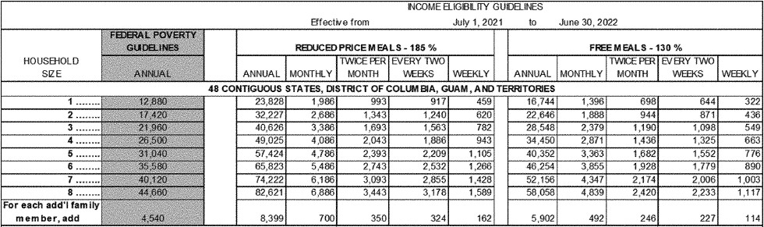

Application forms are being provided to all households, along with a letter to households. To apply for free or reduced price meals, households should fill out one application for the household and return it to the school. Additional copies are available at each school. Applications may be submitted at any time during the year. The information provided by the household is confidential; it will be used for the purpose of determining eligibility. Information may be verified at any time during the school year by school or other program officials.

All children in households with any household member receiving benefits under Assistance Programs (Supplemental Nutrition Assistance Program (SNAP), Family Independence Temporary Assistance Program (FITAP) or Food Distribution Programs on Indian Reservations (FDPIR)) are eligible for free meals. For school officials to determine eligibility, each household that is now receiving benefits from Assistance Programs must provide the case number of a household member as well as the signature of an adult household member.

All other households must provide the following information on the application: names of all household members; the amount of income (before deductions for taxes, Social Security, etc.) each household member receives; how often the person receives the income; where it is from, such as wages, retirement, or welfare; the signature of an adult household member certifying that the information provided is correct; and the last four digits of the social security number of the adult household member who signed the application, or a statement that the household member does not possess one.

Children categorized as foster, homeless, runaway, migrant, or enrolled in state-funded Head Start or Even Start programs, if known, are automatically eligible for free meals. School officials will determine eligibility for free meals based on documentation obtained directly from the program office and notify the household of their eligibility for benefits. The household must notify the school if it chooses to decline benefits.

The household should complete an application if they are not notified of free meal eligibility by: 08/20/2021
Date

If a household member becomes unemployed or if the household size increases, the household should contact the school. Such changes may make the children of the household eligible for meal benefits.

Under the provisions of the free and reduced price policy, Carla Harpin (Determining Official)
will review applications and determine eligibility. If a parent or guardian is dissatisfied with the ruling of the official, he may wish to discuss the decision with the determining official on an informal basis. If the parent wishes to make a formal appeal, he may make either an oral or written response to the following:

Name: Heath Murry

Address: 9560 Hwy 33, Farmerville, LA 71241

Phone Number: 318-368-8051

The policy contains an outline of the hearing procedures.

Non Discrimination Statement
In accordance with Federal civil rights law and U.S. Department of Agriculture (USDA) civil rights regulations and policies, the USDA, its Agencies, offices, and employees, and institutions participating in or administering USDA programs are prohibited from discriminating based on race, color, national origin, sex, disability, age, or reprisal or retaliation for prior civil rights activity in any program or activity conducted or funded by USDA.

Persons with disabilities who require alternative means of communication for program information (e.g. Braille, large print, audiotape, American Sign Language, etc.), should contact the Agency (State or local) where they applied for benefits. Individuals who are deaf, hard of hearing or have speech disabilities may contact USDA through the Federal Relay Service at (800) 877-8339. Additionally, program information may be made available in languages other than English.

To file a program complaint of discrimination, complete the USDA Program Discrimination Complaint Form, (AD-3027) found online at: https://www.usda.gov/oascr/how-to-file-a-program-discrimination-complaint, and at any USDA office, or write a letter addressed to USDA and provide in the letter all of the information requested in the form. To request a copy of the complaint form, call (866) 632-9992. Submit your completed form or letter to USDA by:

mail:
U.S. Department of Agriculture
Office of the Assistant Secretary for Civil Rights
1400 Independence Avenue,
SW Washington, D.C. 20250-9410; or

fax:
(202) 690-7442; or

email:
program.intake@usda.gov.

This institution is an equal opportunity provider

