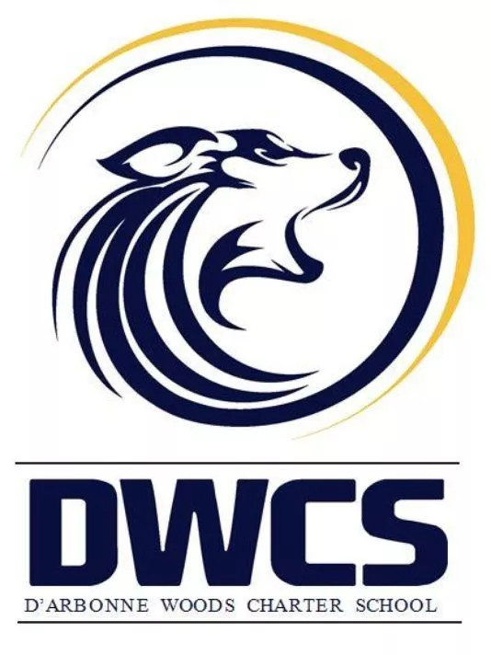
Mini Cubby Cheer Camp

It’s that time again! Mini cheer camp will be hosted by the D’Arbonne Woods cheerleaders on October 8th, 9th, and 10th. The girls will perform during halftime at the home football game on October 11th. The camp is open to K-5th grade students. They will learn the fundamentals of cheerleading, cheers, chants, jumps, and a dance. The cost for camp will be $60 per child; this fee includes: a t-shirt, poms, and a snack every day of camp. If a parent would like to purchase a shirt the cost is $15. Pink out shirts are being offered school wide, so if you plan for your child to attend mini cheer camp then DO NOT purchase a pink out shirt for them (they will receive one for doing cubby camp). We will need this completed form along with all payments turned in to the homeroom teacher by October 3rd. This is such a fun and exciting week for everyone involved! We look forward to teaching your little ones the basics of cheerleading!

Saleena Singleton
Melese Colvin
Sarah Dial

Wolf Cubby Cheer Camp Registration & T-shirt Order Form

Student Name:____________________________________________________________________________________________

Homeroom Teacher:________________________________________________________________________________________

Food Allergies:____________________________________________________________________________________________

Parents’ Names:___________________________________________________________________________________________

Contact Numbers:__________________________________________________________________________________________

Youth Sizes Adult Sizes

S_____ S______ 2XL______

M_____ M______ 3XL______

L_____ L______

XL_____ XL_____

*** The cost of your child’s shirt is included in her camp fees. Adult shirts are $15, add an extra $2 for 2XL and 3XL.

